BLOOD GROUP DETECTION USING FINGERPRINT PATTERNS – A DEEP LEARNING APPROACH

Rohit Kandelkar¹, Yash Jahagirdar², Anandkumar Birajdar^{3*}, Sukanya Bhaskar^{4*}, Rajeshwari Golande^{5*}
¹⁻⁵Department of Computer Engineering (Regional Language), PCCOE Pune, India
rohit.kandelkar22@pccoepune.org , yash.jahagirdar22@pccoepune.org

Keywords: Blood Group Classification, Machine Learning, Deep Learning, CNNs, Fingerprint Recognition, Image Processing, Non-Invasive Blood Typing, Feature Extraction, Medical Diagnostic.

Abstract
Accurate and timely determination of blood group in medical treatments, transfusion medicine, and forensic science. Traditional blood typing methods rely on laboratory-based serological testing, which is accurate but invasive, time-consuming, and resource-intensive. This research proposes a non-invasive approach to blood group classification using fingerprint patterns and deep learning techniques. By leveraging the unique ridge patterns in fingerprints, multiple Convolutional Neural Network (CNN) architectures were evaluated including shallow, custom, and deep variants to identify the most effective approach. The dataset which was sourced from Kaggle was preprocessed thoroughly through class balancing, image normalization, and augmentation to enhance the model robustness. Performance was assessed using standard classification metrics, including accuracy, precision, recall, and F1-score. Interestingly, the Shallow CNN outperformed more complex models, achieving the highest accuracy of 89.49\% with significantly lower training time. These findings highlight the potential of well-optimized shallow networks for biometric-based blood typing offering a non-invasive, cost-effective, and scalable alternative to conventional methods. Future work should focus on increasing dataset diversity (e.g., different age groups), transfer learning, and validating the models in real-world clinical settings to improve robustness and generalizability.

1 Introduction
Fingerprint analysis has been a keystone of biometric identification due to the unique and immutable patterns of ridges, loops, and whorls inherent to every individual. Historically, fingerprints have been used extensively in security systems, forensic science, and identity verification [1]. Other than the usual applications, recent research has discovered possible relation between fingerprint patterns and genetic traits such as blood groups [14].
The classical technique in blood typing is the use of serological techniques, which are reliable but intrinsically invasive and resource and time consuming. Such restrictions have led to investigation of non-invasive means of determining blood groups, especially in cases of remote healthcare camps, in emergency responses, or in the context of forensics [2] [5].
A number of studies have offered to use image processing techniques and machine learning to determine blood groups based on biometric inputs like fingerprints [8] [9]. Previous methods have involved the use of Gray-Level Co-occurrence Matrix (GLCM), K-Nearest Neighbor (KNN), and wavelet feature extraction with shallow machine learning such as Support Vector Machines (SVM) and Back Propagation Neural Networks (BPNN) [3] [10]. Nonetheless, these techniques are limited in their generalization capacity, tend to be sensitive to noise and their performance is relatively poor with accuracies generally measured at less than 80 percent, on small and unbalanced datasets [1] [2].
Recent years have seen extraordinary advances in feature extraction and classification tasks in medical imaging and biometrics achieved through Deep Learning, in the form of Convolutional Neural Networks (CNNs). Based on this development, the current paper showcases several variations of CNN architectures applied to predicting blood groups, using fingerprints as the input. The data, which is retrieved through Kaggle, consists of fingerprints accompanied by the label of blood group and has been preprocessed by use of class balancing, normalizing, and data augmenting methods in order to increase its robustness.
This study intends to propose a robust CNN based approach for non-invasive blood group classification. By combining the areas of fingerprint biometrics and deep learning, this study attempts to address not only the limitations of blood typing traditionally, but also the limitations of previous biometric techniques. Each architecture will be evaluated using standard classification metrics. Interestingly, the results from the study showed that one of the Shallow CNNs achieved better performance than the more complex models, highlighting that a well optimized and lightweight architecture has the potential to be an effective, efficient, and scalable alternative to traditional blood typing. This could also be implemented in real-time settings for healthcare or could unleash an important scenario for field work, especially in low-resource or emergency situations.
2 Literature Review
The relationship between fingerprint patterns and blood group classification has been a topic of increasing interest in biometric research. Fingerprints, widely used in forensic and security applications, contain unique ridge characteristics which have been hypothesized to correlate with genetic and physiological traits, including blood type [14]. Various methods have been proposed to exploit this correlation using statistical, machine learning, and deep learning approaches.
Early research employed traditional statistical models for blood group classification using fingerprint features. This study [1] proposed a system using Ordinary Least Squares (OLS) and Multiple Linear Regression, achieving an accuracy of 62%. However, this approach relied heavily on handcrafted features and suffered from limited predictive performance, particularly in complex, high-dimensional image data.
Several other studies applied basic machine learning techniques such as Gray-Level Co-occurrence Matrix (GLCM), wavelet transforms, and minutiae feature extraction for image analysis. These extracted features were classified using models like the Back Propagation Neural Network (BPNN), with some studies reporting accuracies up to 80% [2]. While promising, these methods lacked generalizability due to the limited feature representation capacity and small, often imbalanced datasets.
Image processing techniques have also been explored to automate blood group detection. These studies [3] [4] proposed spectrophotometric systems that analyze agglutination reactions captured through CCD cameras. Similarly, these researchers [5] [12] designed image-based systems to determine blood types in emergency scenarios. These systems were effective in constrained environments but remained dependent on physical blood samples, thereby failing to overcome the invasiveness of conventional testing.
Recent studies have explored genetic techniques for blood group prediction using Single Nucleotide Variant (SNV) mapping and Massively Parallel Sequencing (MPS) [13]. While these approaches offer high accuracy and complete phenotyping, they require sophisticated infrastructure, extensive bioinformatics analysis, and are not feasible for non-invasive or real-time applications.
In the domain of biometric-based health diagnostics, this study [11] developed a non-invasive method to estimate haemoglobin and glucose levels using photoplethysmographic (PPG) signals from fingertip videos. Although this study demonstrates the potential of biometric signals for medical analysis, it does not directly address blood group classification.
Moving towards deep learning, these studies [9] [10] proposed CNN-based models for fingerprint-based blood group classification. These models demonstrated higher accuracy than classical approaches but often lacked robust dataset preprocessing, detailed performance metrics, and comparative validation with established baselines. Additionally, several of these studies did not address class imbalance, which can significantly bias model performance.
Considering these limitations, this research work investigates and compares multiple CNN-based deep learning architectures for blood group prediction using fingerprint images. Unlike prior studies, this work not only applies deep feature extraction but also conducts a comprehensive evaluation across shallow, custom and deep CNN variants using standard classification metrics. Notably, the shallow CNN outperformed more complex models, highlighting that architectural simplicity when paired with proper preprocessing can lead to superior performance in biometric classification tasks. This study thus addresses gaps in prior research by providing both a transparent dataset pipeline and comparative benchmark of deep learning models, offering a scalable and non-invasive approach for real-time blood group identification.
3 Methodology
The goal of this study is to assess and contrast the performance of various deep learning architectures for fingerprint-based blood group classification, ensuring methodological transparency and reproducibility. The dataset, obtained from Kaggle, contains fingerprint images labelled with eight distinct blood groups: A+, A-, B+, B-, AB+, AB-, O+, and O-. A consistent preprocessing pipeline was applied before training four models: a Shallow CNN, Custom CNN, a Deep CNN, and a Multilayer Perceptron (MLP). All architectures were trained on the same balanced dataset using the same data augmentation and splitting techniques, so differences in performance can be reliably attributed to architectural differences and not differences in preprocessing.
3.1 Dataset Preparation and Preprocessing
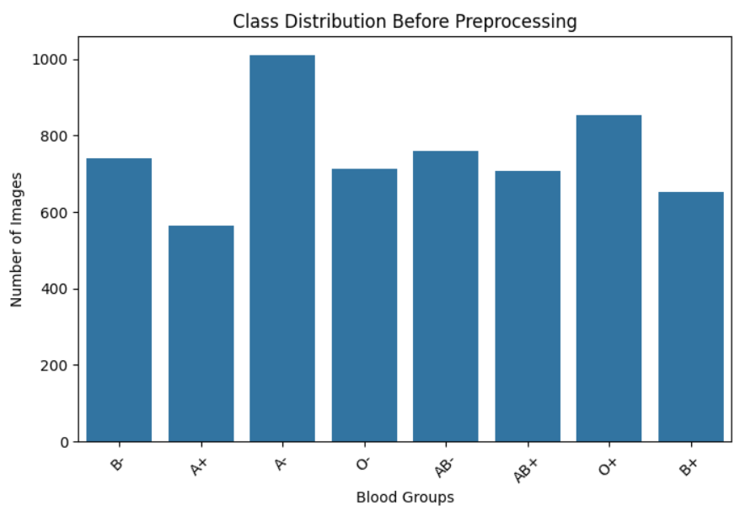
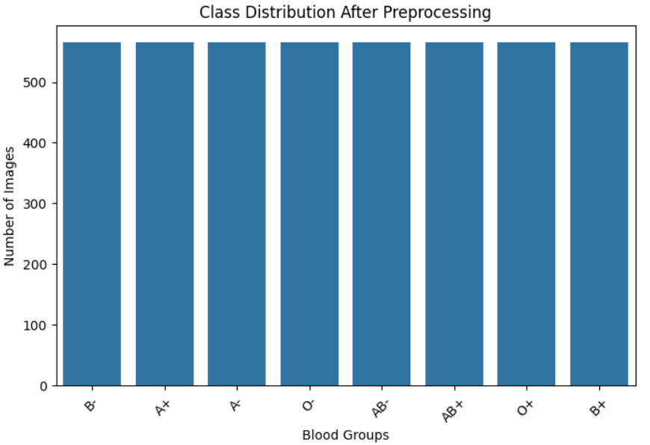
Fig. 1. Class distribution before and after preprocessing
The dataset used in this study was the publicly available, Fingerprint-Based blood group dataset hosted on Kaggle. The dataset collected grayscale fingerprint images and was labelled with one of the eight blood groups: A+, A-, B+, B-, AB+, AB-, O+, and O-. Each blood group was lumped into a peculiar directory, while the dataset has an unequal number of samples corresponding to each blood group category thus resulting in an initial class imbalance.
In order to restrict bias and ensure a fair model evaluation, the dataset was balanced by under-sampling each class containing the same number of images as the smallest class. This method was beneficial as it not only avoided the class imbalance but also preserved the variability of ridge patterns in each blood group category. Images were then resized to a dimensions of 128 x 128 pixels so that all models would be the same input dimension. Normalizing intensity values to the range of [0.1] contributed to the stabilization of the training process and increased the speed of convergence.
TensorFlow’s ImageDataGenerator was used to add more data to the training set, improving the models generalization and reducing the likelihood of overfitting. The augmentation technique involved small random rotations, zoom functions, and horizontal flips, making sure that the models see different fingerprint patterns during training while not changing the basic structure of the ridges. This augmented dataset better captured the variability present in the actual fingerprint capture conditions, such as scanner alignment, rotation, or partial captures.
Lastly, the dataset was divided between training and testing sets in the general 80:20 ratio, ensuring that no samples from the same person were in both subsets. This division facilitated accurate evaluation of the ability of the models to generalize when applied on unseen data.
3.2 Methodological Workflow
The experimental process followed in this current study includes four key stages: model selection, implementation of architecture, training, and testing. There were four different architectures used to evaluate the performance: Shallow CNN, originally suggested Custom CNN, Deep CNN, and Multilayer Perceptron (MLP) baseline. All the models were trained using the same preprocessed dataset outlined in section 3.1 so that the differences in performance can only be due to architectural differences and not due to the preprocessing inconsistencies.
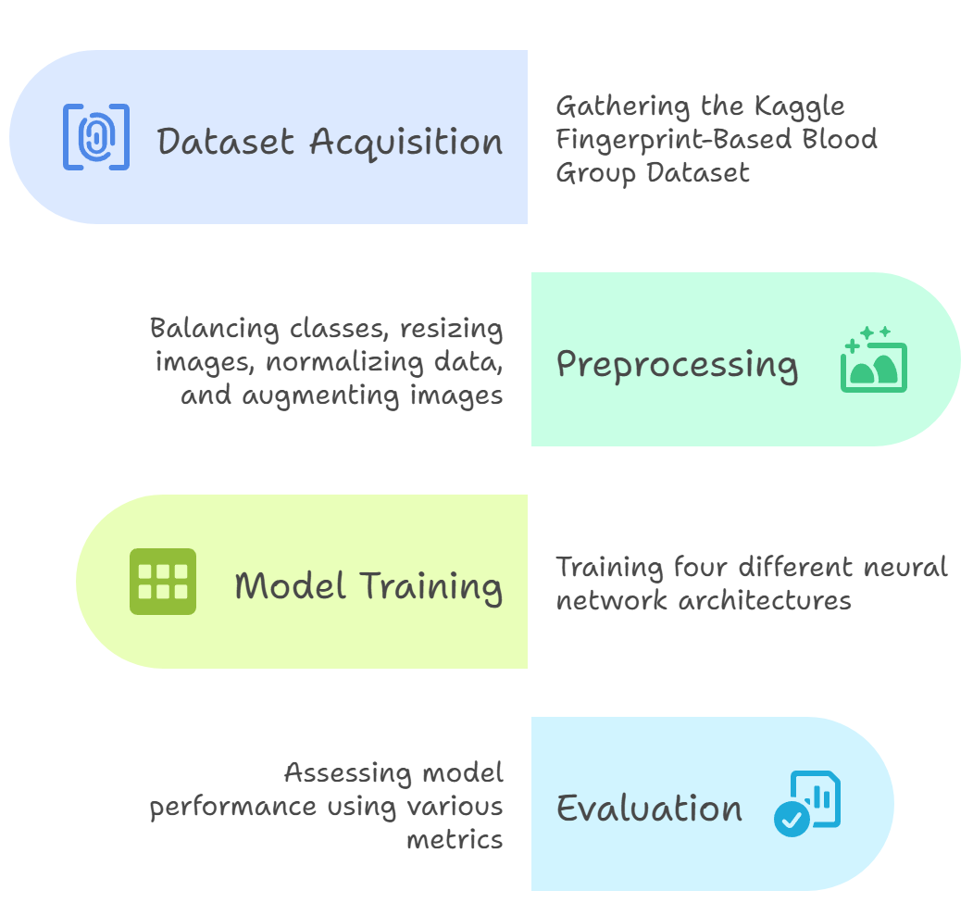
Fig. 2. Methodological Workflow
3.3 Model Architecture
Four models were implemented and their performance compared:
- A Simple CNN with low convolutional depth for efficient feature extraction.
- A Custom CNN with moderate depth and regularization to achieve good accuracy, while reducing training time.
- A Deep CNN with extended convolutional layers and batch normalization for enhanced feature learning at higher computational expense.
- An MLP baseline without convolutional layers to highlight the importance of spatial feature extraction in fingerprint classification.
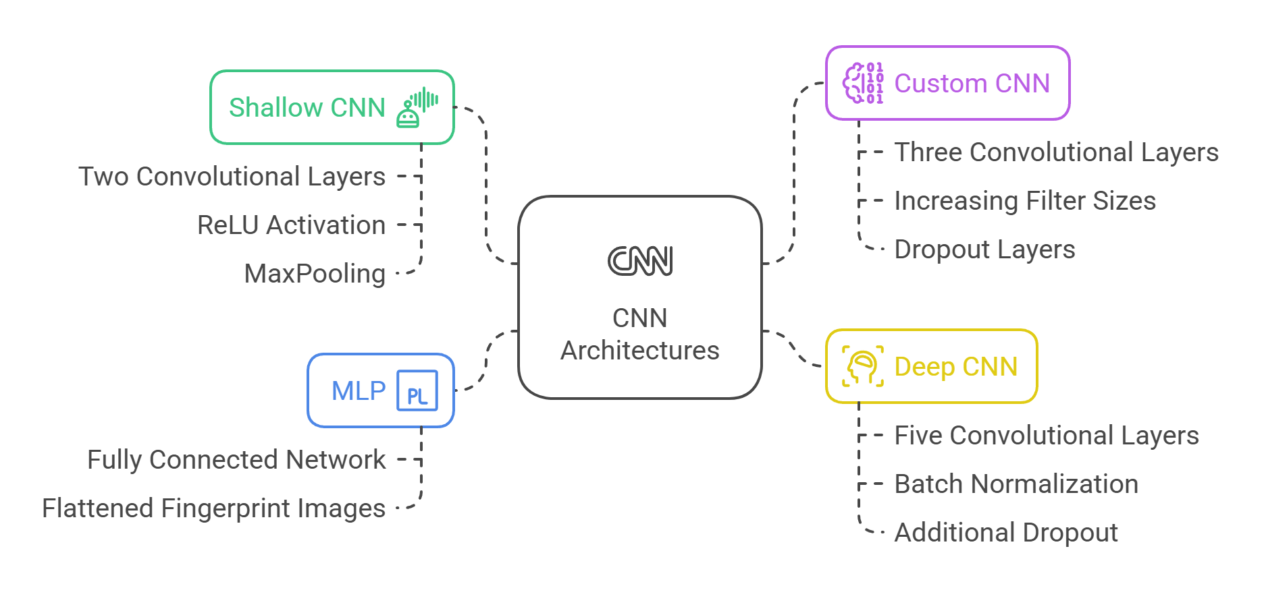
Fig. 3. CNN Architectures Used
3.4 Training Configuration
All models were compiled with Adam Optimizer, having a learning rate of 0.001 and cross-entropy loss function. Training ran up to 15 epochs, per model, with early stopping based on validation loss to reduce overfitting. The models’ performances were then evaluated and compared on the unseen testing set using the measures: accuracy, precision, recall, and F1-score. To ensure comparability, all experiments were conducted under identical hardware and software environments.
4 Results and Evaluation
The performance of the four implemented architectures: Shallow CNN, Custom CNN, Deep CNN, and MLP was evaluated on the unseen test set using the metrics outlined in section B of 3.2. All models were trained under identical preprocessing and training conditions to ensure that performance differences were attributable solely to architectural variations.
4.1 Quantitative Analysis
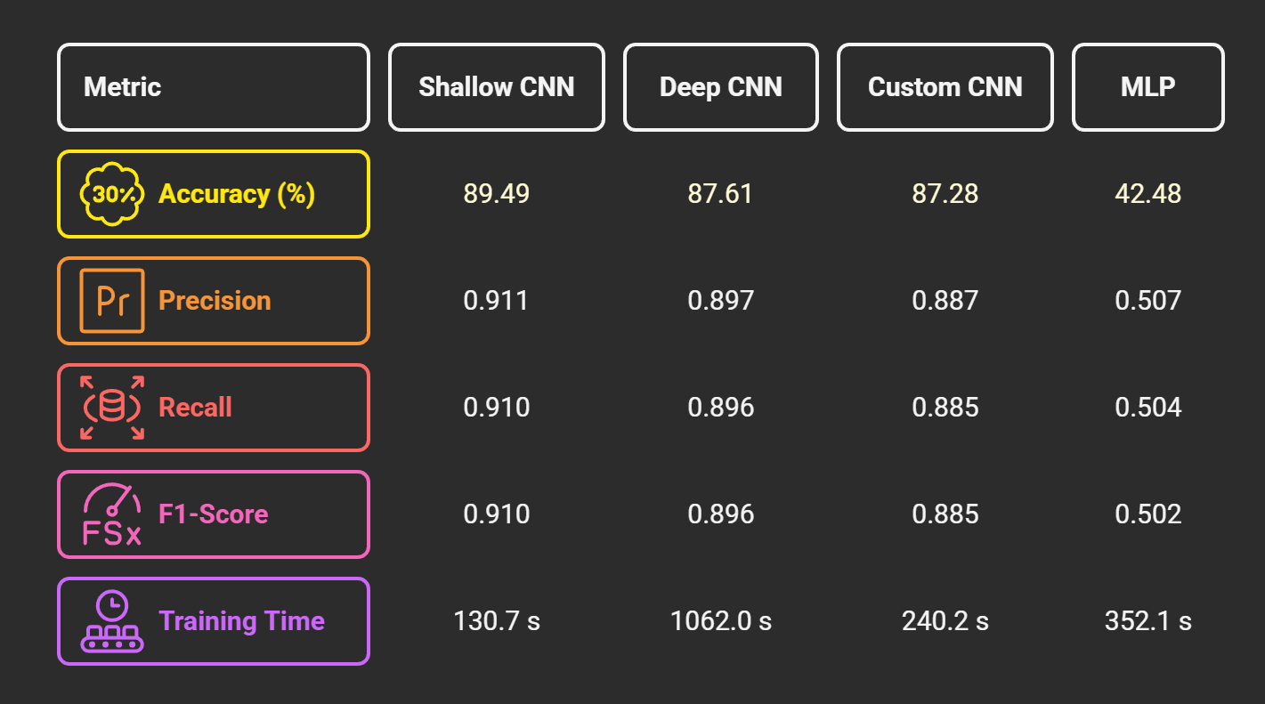
Fig. 4. Comparison of Performance of all CNN Architecture and MLP
The results indicate that the Shallow CNN achieved the highest overall accuracy (89.49%) while also being the fastest to train. Both the Deep CNN and Custom CNN produced similar performance, albeit with higher computation costs in the case of the Deep CNN. The MLP performed significantly worse across all metrics, highlighting the necessity of convolutional layers for spatial pattern recognition in fingerprint-based classification.
4.2 Confusion Matrix Analysis
Confusion matrices were generated for each model to help show the per-class performance and misclassification patterns. Shallow CNN displayed strong diagonal dominance, with minimal misclassifications and balanced performance across all blood group classes. Custom CNN and Deep CNN achieved comparable results but exhibited slightly higher off-diagonal misclassifications for certain groups (e.g., A+ vs AB+). MLP confusion matrix was noisy, with substantial misclassification across multiple classes, reflecting its inability to capture spatial ridge features.

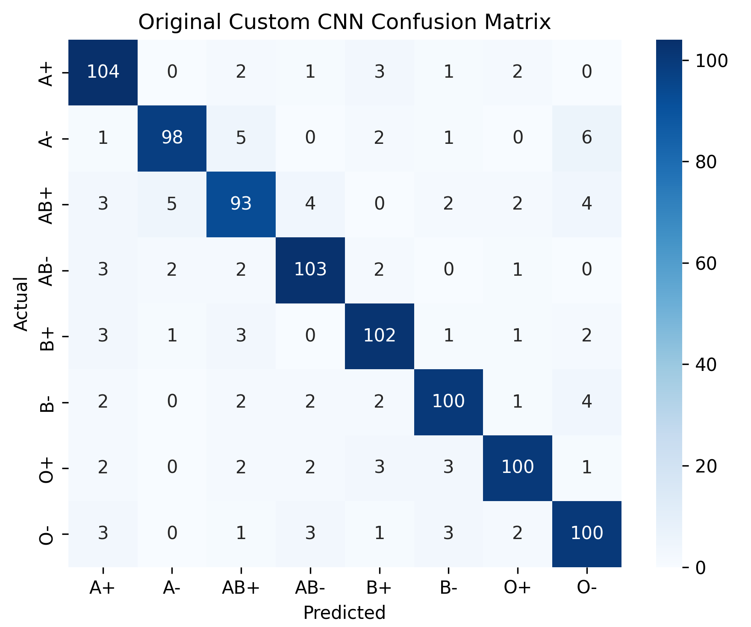
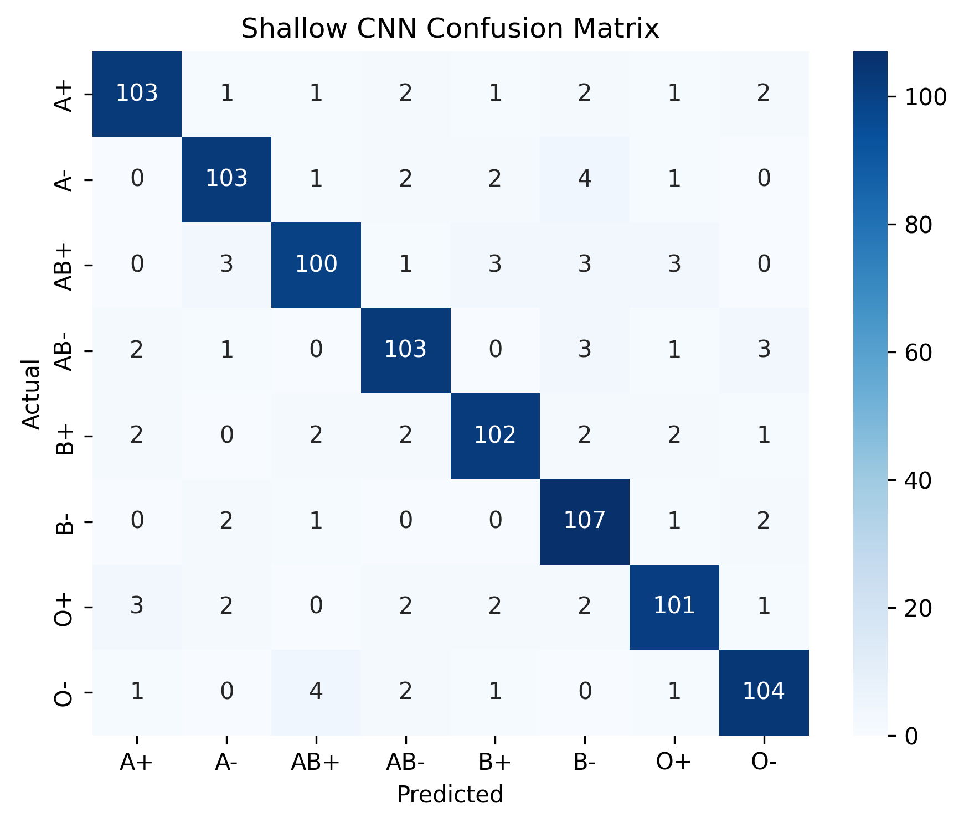
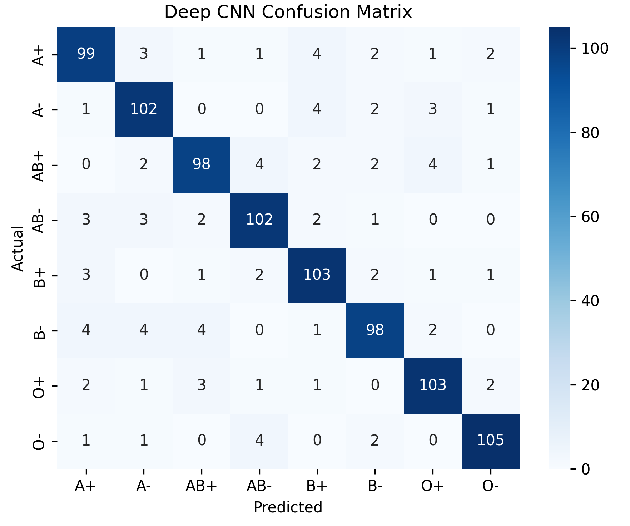
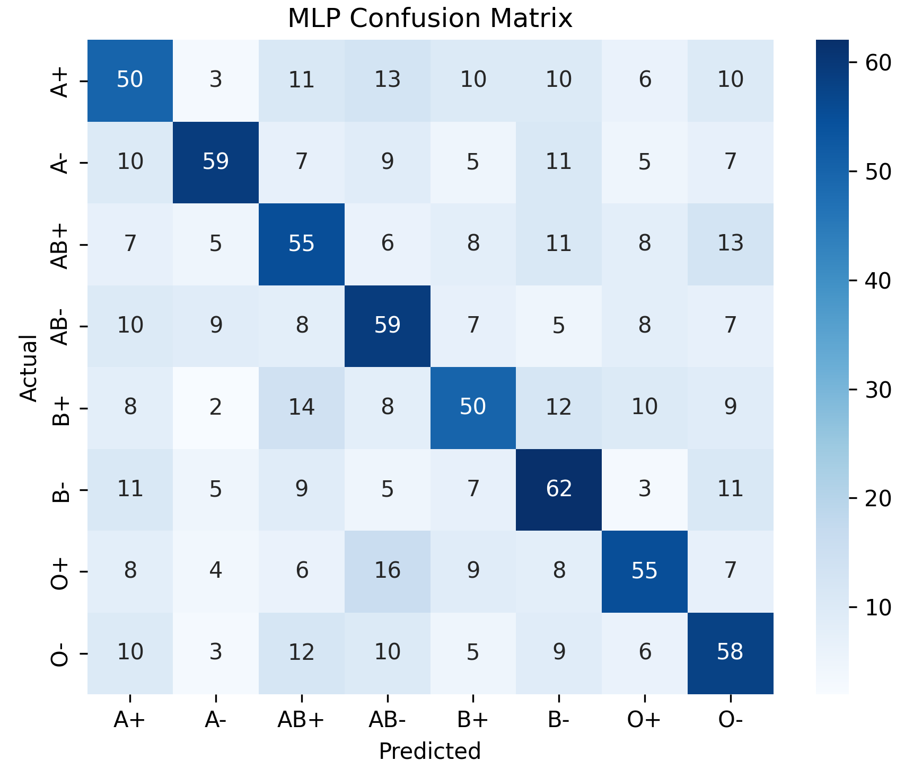
Fig. 5. Confusion Matrices of all four CNN Architectures and MLP
4.3 Comparative Evaluation and Observations
The comparative evaluation yields the following key observations:
- The Shallow CNN demonstrated superior generalization while significantly reducing training time, making it the most computationally efficient choice without compromising performance.
- The Deep CNN, despite its increased architectural complexity, provided only marginal performance gains over the Custom CNN and incurred a substantial computational overhead.
- The MLP’s poor performance confirms that convolutional operations are essential for fingerprint-based biometric classification.
- The Shallow CNN maintained strong test performance without signs of overfitting, outperforming deeper models in both consistency and robustness.
4.4 Discussion of Results and Novelty
The experimental results demonstrated that the proposed framework, particularly when implemented with a Shallow CNN, achieves superior performance compared to both deeper CNN architectures and a fully connected MLP baseline. This finding is noteworthy when contextualized against prior literature, where most fingerprint-based biometric classification studies have favoured either traditional machine learning methods with handcrafted features (e.g., GLCM, KNN, SVM) or deep CNN architectures with increased depth to improve accuracy. As reported earlier works, conventional feature extraction methods combined with shallow classifiers typically achieved classification accuracies below 80% on smaller, imbalanced datasets, and deeper CNN models in related biometric studies rarely exceeded 88% accuracy without resorting to transfer learning or large-scale datasets.
The present study contributes a methodological refinement through rigorous dataset balancing, normalization, and augmentation, combined with a streamlined convolutional architecture, it is possible to surpass the accuracy of both deeper CNNs and reported baseline models in the literature while significantly reducing computational cost. This is particularly relevant for deployment in real-time, resource limited environments, where the trade-off between accuracy and efficiency is critical.
Unlike prior studies where performance claims often lack standardized baselines, this work provides a fair, controlled comparison, highlighting that model simplicity can yield optimal results when paired with carefully engineered preprocessing pipelines.
Finally, by publicly detailing the dataset source, preprocessing methods and architectural settings, this work adds to reproducibility, an aspect which is often missing in prior fingerprint-based biometric classification research. This level of transparency not only enhances the credibility of the results, but also confirms the original contribution that optimal performance in fingerprint-based blood group detection could be achieved without overheads of architectural complexity.
5 Conclusion
This paper examined the blood group classification based on fingerprint in terms of multiple deep learning models Shallow CNN, Custom CNN, Deep CNN and MLP in a standard preprocessing and training pipeline. The findings indicated that the Shallow CNN had the highest accuracy (89.49%) and also needed much less training time than deeper architectures, and have undermined the popular belief that deep model architectures automatically results in high performance.
This work directly handles the most important gaps in previous literature where results were commonly reported without standardized baselines or full methodological reporting. The results emphasize that simple architectural designs with a strong preprocessing capability may be more effective in biometric classification tasks than more complex model architectures, and so the architecture is especially useful in real-time and resource-limited systems.
Regardless of these encouraging outcomes, the research is restricted by the size and variety of the researcher obtained dataset that was retrieved from a publicly available repository on Kaggle. Future studies are necessary to extend the dataset to cover real-life fingerprint samples of different populations and different acquisition conditions, transfer learning strategies, and incorporation of the method into live acquisition systems to be used in clinical or forensic settings.
In summary, this research provides a reproducible, computationally efficient, and accurate approach to non-invasive blood group determination, offering a scalable alternative to conventional serological testing and contributing meaningful insights to the growing field of biometric-based medical diagnostics.
6 Acknowledgment
The authors would like to thank the organizers of ICATES 2025 for their guidance and valuable reviewers feedback, which greatly contributed to improving the quality of this work. Sincere gratitude to the contributors of the publicly available Fingerprint-based Blood Group Dataset on Kaggle, whose work made this study possible.
6 References
[1] Vijaykumar, Patil N., and D. R. Ingle, `A Novel Approach to Predict Blood Group using Fingerprint Map Reading', 2021 6th International Conference for Convergence in Technology (I2CT), IEEE, 2021.
[2] D. Siva Sundhara Raja and J. Abinaya, `A Cost-Effective Method for Blood Group Detection Using Fingerprints', International Journal of Advance Study and Research Work, vol. 2, no. 3, pp. 1-10, March 2019, doi: 10.5281/zenodo.2591955.
[3] S. Pimenta, G. Minas and F. Soares, 'Spectrophotometric approach for automatic human blood typing', 2012 IEEE 2nd Portuguese Meeting in Bioengineering (ENBENG), Coimbra, Portugal, 2012, pp. 1-4, doi: 10.1109/ENBENG.2012.6331340.
[4] S. Pimenta, F. Soares and G. Minas, `Development of an automatic electronic system to human blood typing', Annual International Conference of the IEEE Engineering in Medicine and Biology Society, vol. 2012, pp. 2712-2715, 2012, doi: 10.1109/EMBC.2012.6346524. PMID: 23366485.
[5] Ferraz, Ana, `Automatic system for determination of blood types using image processing techniques', 2013 IEEE 3rd Portuguese Meeting in Bioengineering (ENBENG), IEEE, 2013.
[6] T. Gupta, `Artificial Intelligence and Image Processing Techniques for Blood Group Prediction', 2024 IEEE International Conference on Computing, Power and Communication Technologies (IC2PCT), Greater Noida, India, 2024, pp. 1022-1028, doi: 10.1109/IC2PCT60090.2024.10486628.
[7] G. Ravindran, et al., `Determination and classification of blood types using image processing techniques', International Journal of Computer Applications, vol. 157, no. 1, pp. 12-16, 2017.
[8] T. Nihar, K. Yeswanth, and K. Prabhakar, `Blood group determination using fingerprint', MATEC Web of Conferences, vol. 392, p. 01069, 2024, doi: 10.1051/matecconf/202439201069.
[9] S. Dannana and D. Y. V. Prasad, `Blood group detection using ML classifier', International Journal of Health Sciences, vol. 6, Suppl. 1, pp. 4395-4408, 2022, doi: 10.53730/ijhs.v6nS1.5830.
[10] J. Sai Ganta, M. Rishitha, Y. Jaya Surya Pulivarthi, and M. Roopa, `Blood Group Detection Using Image Processing and Deep Learning', International Research Journal of Engineering and Technology (IRJET), vol. 11, no. 4, pp. 97-103, April 2024, doi: 10.17148/IJARCCE.2015.4123.
[11] M. R. Haque, S. M. T. U. Raju, M. A.-U. Golap and M. M. A. Hashem, `A Novel Technique for Non-Invasive Measurement of Human Blood Component Levels from Fingertip Video Using DNN Based Models', IEEE Access, vol. 9, pp. 19025-19042, 2021, doi: 10.1109/ACCESS.2021.3054236.
[12] A. N. Banu and V. Kalpana, `An Automatic System to Detect Human Blood Groups of Many Individuals in a Parallel Manner Using Image Processing', International Journal of Pure and Applied Mathematics, vol. 118, no. 20, pp. 3119-3128, 2018.
[13] R. S. McBean, C. A. Hyland, and R. L. Flower, `Approaches to Determination of a Full Profile of Blood Group Genotypes: Single Nucleotide Variant Mapping and Massively Parallel Sequencing', Computational and Structural Biotechnology Journal, vol. 11, no. 19, pp. 147-151, 2014, doi: 10.1016/j.csbj.2014.09.009.
[14] H. O. Smail, D. A. Wahab, and Z. Y. Abdullah, `Relationship between pattern of fingerprints and blood groups', Journal of Advanced Laboratory Research in Biology, vol. 10, no. 3, pp. 84-90, 2019.

